iWantToDine.com/RehobothDining.com

User Instructions

v 1.1
June 21, 2020

Welcome to iWantToDine/RehobothDining.com
iWantToDine.com/RehobothDining.com is a fine dining web app that provides up to date menu and entertainment information.
It has online menus, restaurant pages, associate pages, entertainment pages and a photo wall.
The concept is simple, all the information that is important to your customers in one place.

Current customer experience
When a customer visits Rehoboth and wants to get something to eat they walk around town and look at menus that are posted outside Restaurants.
They also go online and try to find restaurant information, but often it is out of date and full of biased reviews.
We aim to change this with iWantToDine.com/RehobothDining.com.

A new customer experience

This fine dining app does the walking and searching for the customer. Let's say they want a steak. They press the steak button and all the steak entrees in town are listed. They press fish and all the fish options show up. They press daily specials and all the daily specials show up.

This is the inspiration for our fine dining web app that only contains curated information submitted by the Restaurant owners. This makes the experience personal, just like the server was handing the customer the menu and telling them today's specials.

There is no app today that gives that experience. This will be exciting! The current test market is Rehoboth Beach Delaware.

The web app is in its beta phase and currently free to use. Please help us make it the best restaurant app out there. Once it is perfected we plan to commercialize it.

Use this manual to setup a restaurant account. It is as simple as registering with an email address. Note: Before your restaurant goes live we will need to verify the restaurant owner. In the mean time it will be in sandbox mode which will allow you can enter data but the data will not be visible to the public.

I you have any questions please contact me at jbailey@jimmysoftllc.com.

-Jim Bailey

Table of Contents
Welcome to iWantToDine/RehobothDining.com 2
Current customer experience 2
A new customer experience 2
How the customer uses the app 4
Menu items 5
Menu Categories 5
Food categories 5
Price categories 6
Restaurants list 7
Restaurant detail 8
Associates 9
Entertainment Items 10
Photo wall 11
Creating an account 12
Logging into your account 13
Create your restaurant 14
Adding menu items 15
Editing, copying, and deleting menu items 16
Adding entertainment items 17
Editing, copying, and deleting entertainment items 18
Adding associates 19
Permissions 19
Add an associate with no access 20
Add an associate with read, edit or admin access 21
Adding, cropping and deleting associate pictures 22
Editing and deleting associates 23
Adding photo items 24
Editing and deleting photos 25
Adding menu days 26
Editing, copying, deleting and menu days 28

How the customer uses the app
The app has six pages listed at the bottom, menu items, restaurant list, associates list, entertainment items, photo wall and information.
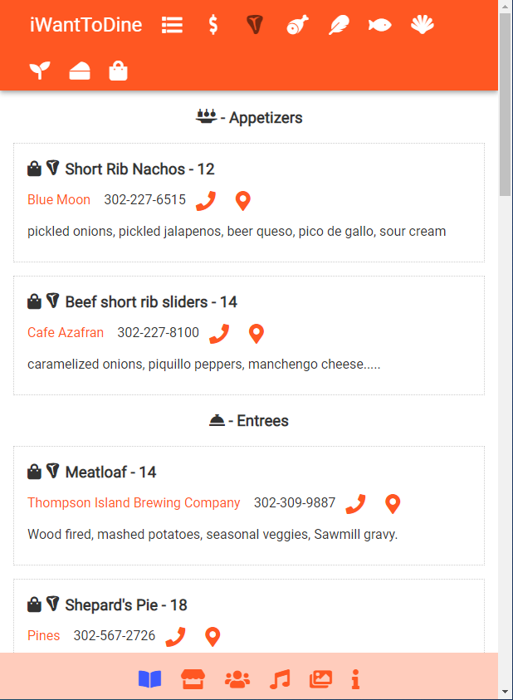
The customer selects one of these pages.
Menu items
Information
Associates
Restaurants
Entertainment
Photo wall

Menu items

When the customer presses the menu items button a menu will display with Specials, Appetizers and Entrees already selected.

Menu Categories
The customer can then customize the menu by pressing the menu categories button.
A menu will popup where they can select the categories they are interested in. The selected categories will turn blue. The icons represent:

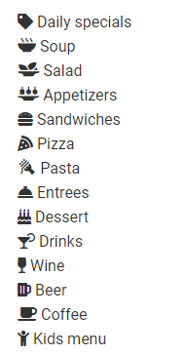
Food categories
Once the customer has selected the desired menu categories they can select the foods they are interested by clicking the food icons.
The selected foods will darken. Menu items with those foods will show up in the list. The icons represent:
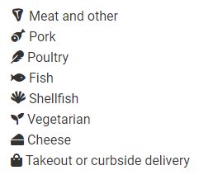

Price categories
The customer can set the price range by clicking on the $ button. A menu will popup where they select the price points they are interested in. Blue indicates an active price point.
One or more price points can be selected. For example if the customer wants prices from 0 to 35 they activate both the $ and $$. The icons represent:
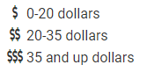

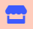
Restaurants list
When the customer presses the restaurant button a list of restaurants around them will show up with a brief description.
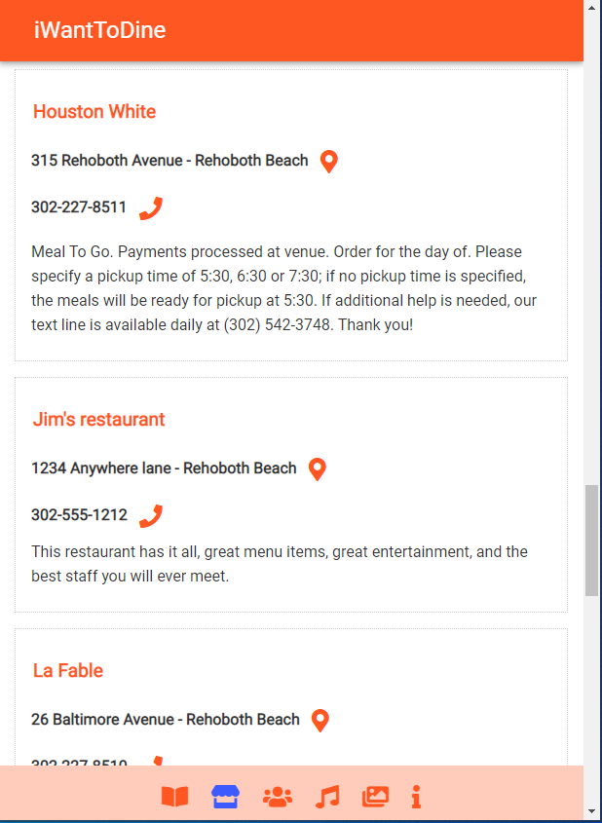
The customer can then get the details of the restaurant by clicking the name. A full menu, associates, entertainment and a photo wall will show. They can also call using the phone icon, or goto the location on google maps by pressing the location pin.

Restaurant detail
The following is an example of a restaurant detail page. This page can be accessed from any page that has a restaurant link. These links exist on menu items page, restaurants page, associates page, entertainment page and photo wall.
The restaurant detail lists the entire menu, entertainment for that day, associates, and photos from the photo wall.
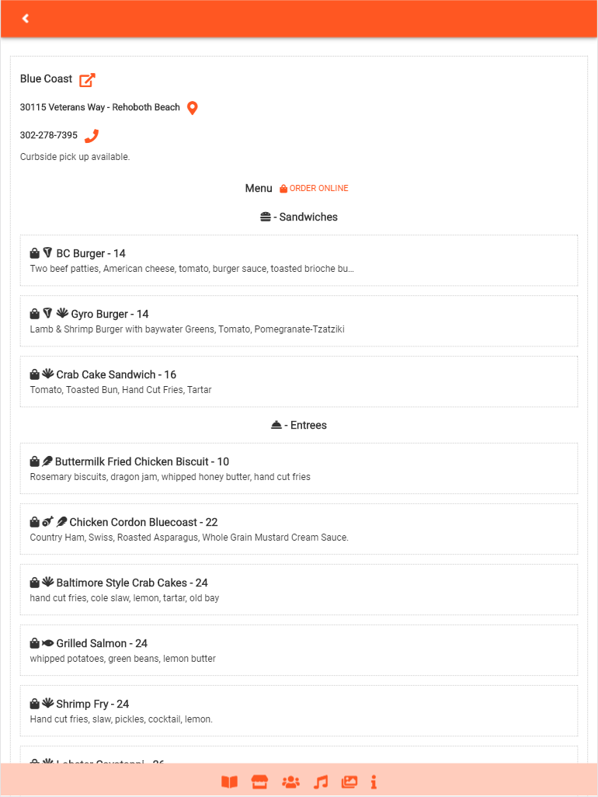
From here the customer can go back, click a link to the restaurant web page, order online, go to the location or call.


Associates
The following will display when the customer presses the associates button.
This page will consist of a list of the restaurant associates with their title, picture and short bio about them.
The purpose of this is to familiarize the public with the people who are crafting and serving the wonderful food in town. Green dots will show who is in the restaurant on that day.
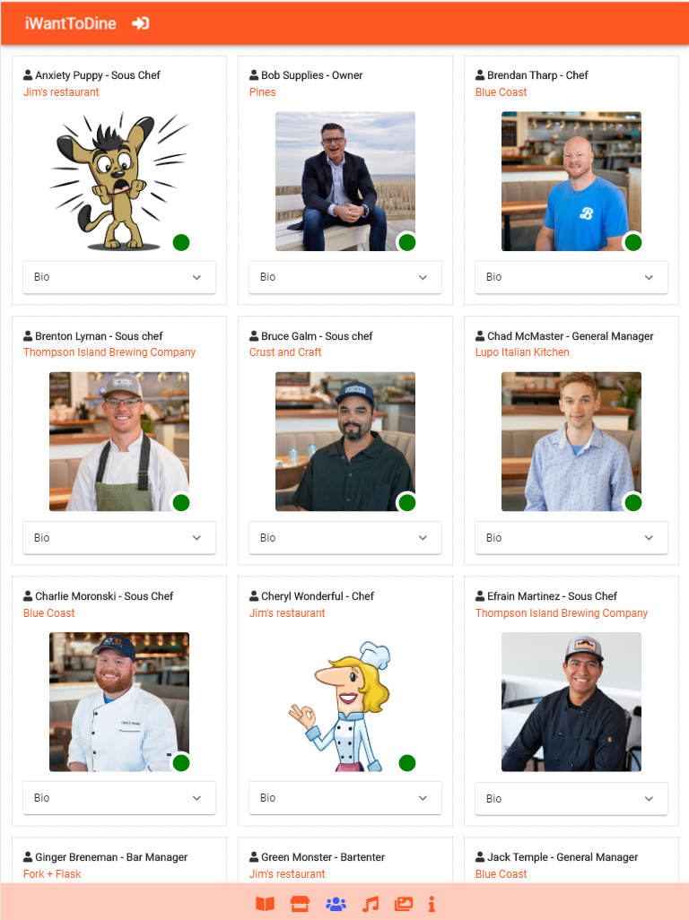
This allows the customer to be engaged with restaurant community. For example if they have a favorite chef, bartender or server working that night they probably would drop in.


Entertainment Items
The following will display when the customer presses the entertainment button.
A list will show all the entertainment happening in town that day.
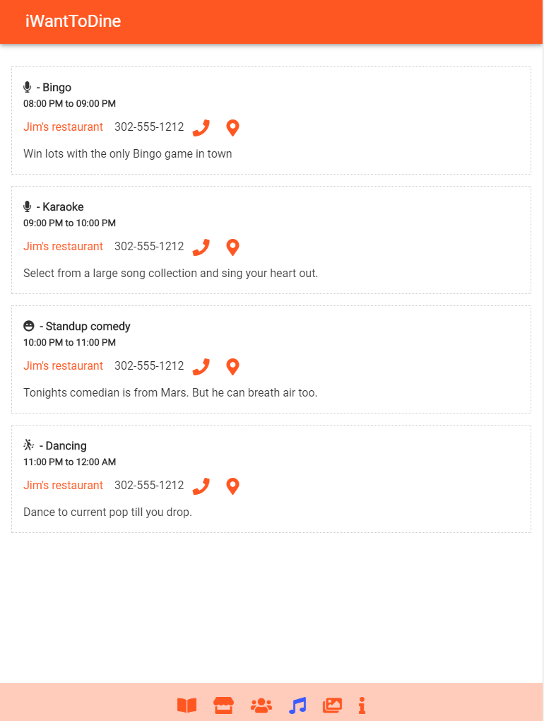


Photo wall
The following will display when the customer presses the photo wall button.
A mosaic of photos will display showing pictures of dishes, people, and events. Basically anything the restaurant wants to post like food, people, selfies, pets, nature shots...
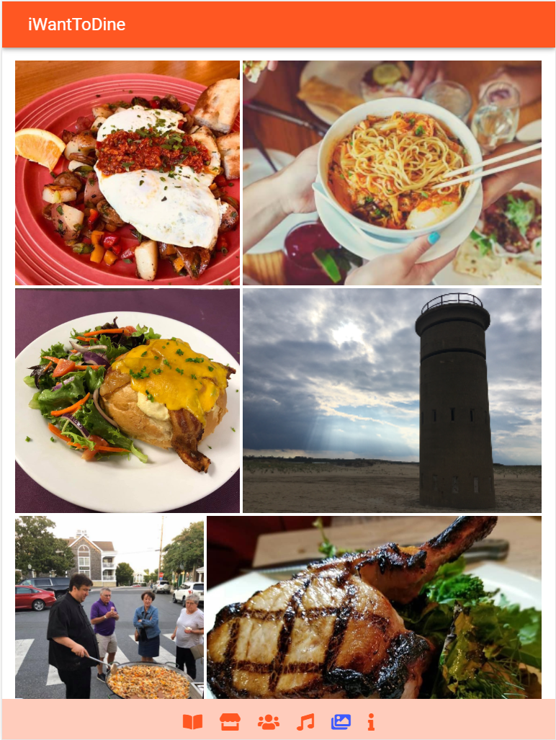
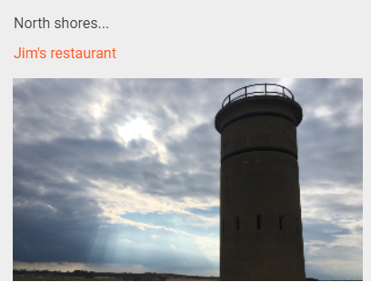
When the customer clicks on one of the pictures it will shrink to expose a caption and a link.

Creating an account
To use iWantToDine a user account needs to be created. You can have one or many user accounts for the same restaurant with different access levels. Also a user can access more than one restaurant if your company has more than one restaurant.

To setup an account click on the associates page button.

Then a login button will display at the top. Press it and the following will be displayed.
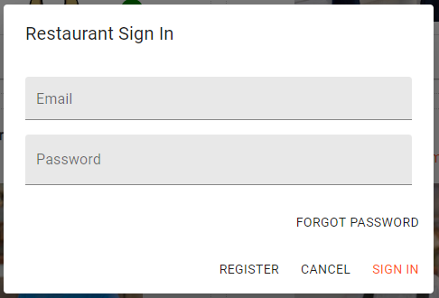

Press register to create a new user. The following will be display. Enter your email address and a password and press register.
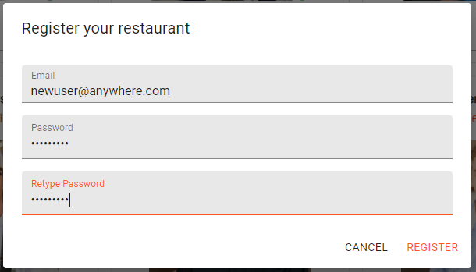
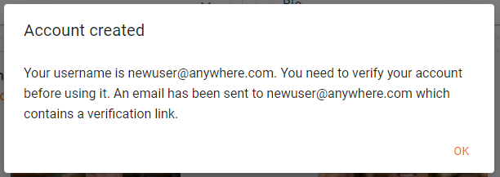
After that a dialog will indicate that the account is created. You will be sent an email that will contain a verification link that you must click before you can log in.

Logging into your account
To log into your account click on the associates page button.
Then a login button will display at the top. Press it and the following will be displayed.
Enter the email and password you registered with and press sign in.
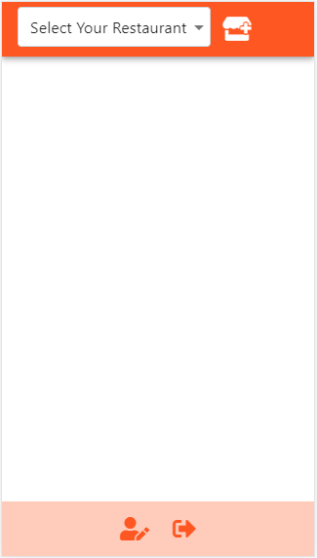
The following will display.


Create your restaurant
To create a restaurant press the add restaurant button.
The following will display. Enter your restaurant information and press save.
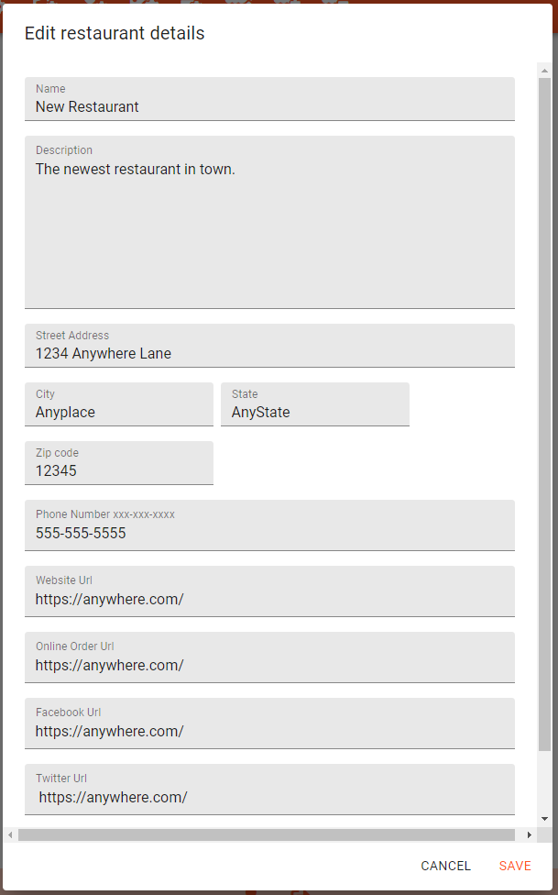
Once you have created your restaurant you can select it under the drop down and the following will be displayed. The buttons are as follows, restaurant settings, menu settings, entertainment settings, associate settings, photo gallery settings, menu day settings, edit restaurant, add restaurant and delete restaurant.
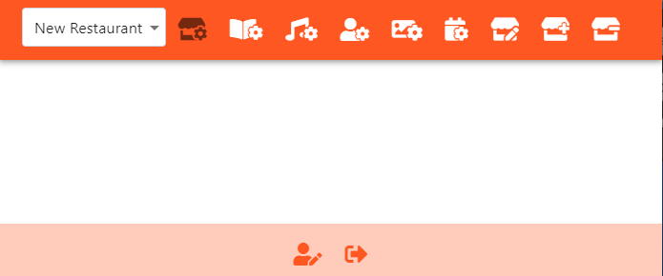

Adding menu items
Click on menu settings to add, edit or delete menu items. Any number of menu items can be created. You can think of Menu items as an inventory of dishes. Using this inventory you can offer certain dishes on certain days. Menu days, discussed later, will give you the ability to schedule when the menu items are displayed.

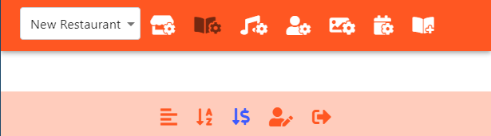
To add a menu item press the add menu item button.
The following will be displayed. Enter a title and description of the menu item, select the menu category, ingredients and price. Press save. Note: if you hover over the icons a tool tip will tell what each icon represents.
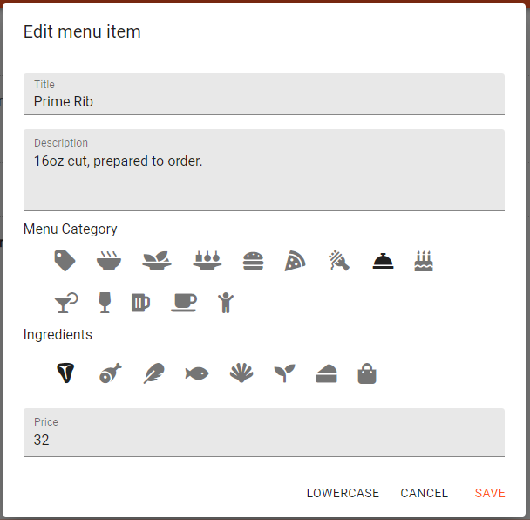

Editing, copying, and deleting menu items
Once you have created several menu items they will show up in a sorted list for each menu category. Sort them by price or alphabet by pressing the sort buttons below. Show or hide the description.
Edit, copy and delete menu items by pressing the corresponding buttons on the menu item.
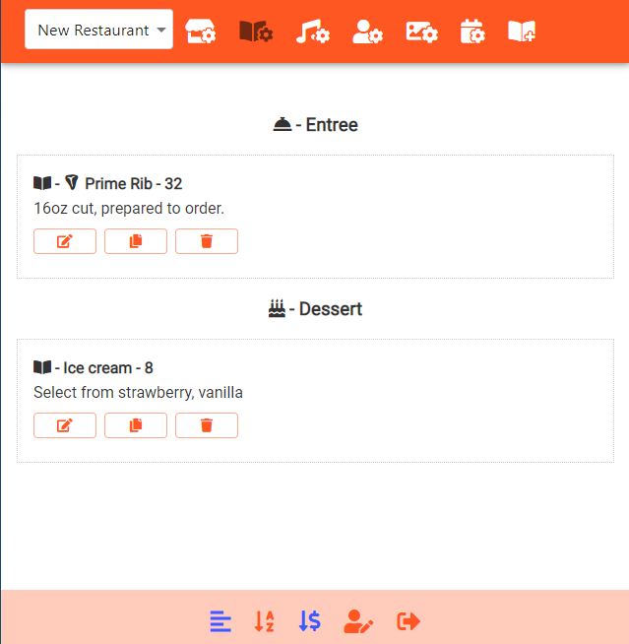

Adding entertainment items
Click on entertainment settings and the following will be displayed.
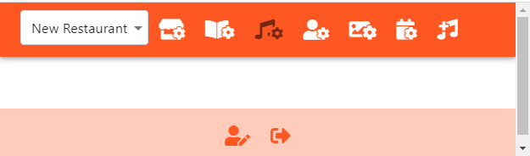

To add an entertainment item press the add entertainment button.
The following will be displayed. Enter a title and description of the entertainment item, select the category, and start end times. Press save.
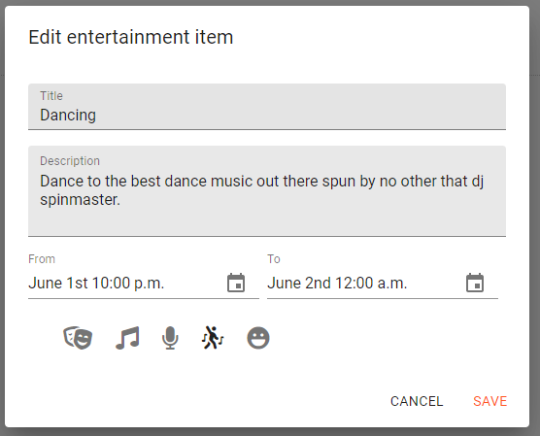
Note: if you hover over the icons a tool tip will tell you what each icon represents.
Important: For midnight make sure 12 am is selected and is on the next day as shown.

Editing, copying, and deleting entertainment items
Once you have created several entertain items they will show up in a chronological list. You can edit, copy and delete them pressing the corresponding buttons on the entertainment item.

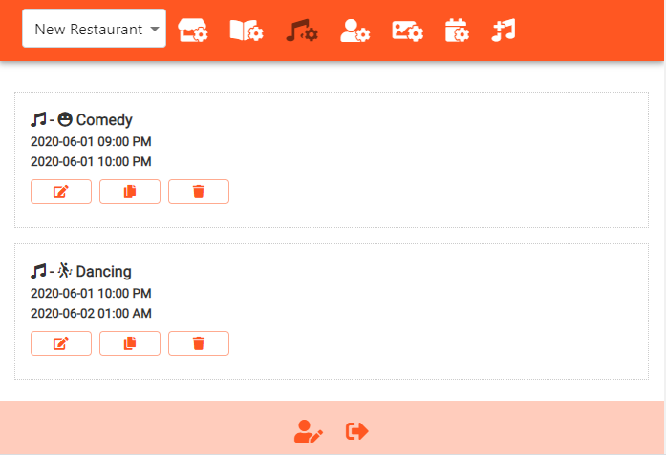

Adding associates
Click on associates settings and the following will be displayed. Associates can have various levels of permission: none, read, write, and admin.
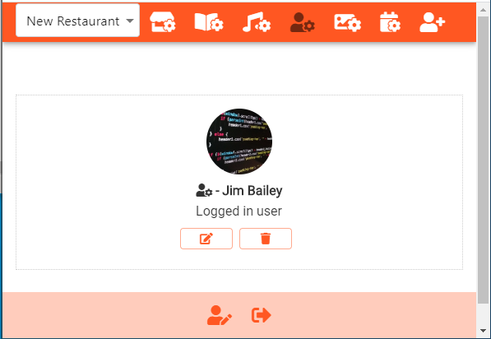

Permissions
- None – at this permission level the associate has no access to the restaurant account. This level should be used for associates that have no need to edit restaurant items but still will be listed as an restaurant associate. Their data can be entered by a user that has edit or admin access.
- Read – at this permission level the associate can read the items in the restaurant account and control their own information. For example they can to update their pictures or bio as they wish but they cannot create, edit or delete other items.
- Edit – at this permission level the associate can edit items in the restaurant. This level is good for associates who need to maintain data in the app but cannot delete items.
- Admin – at this permission level the associate has full access and can do anything.


Add an associate with no access
To add an associate press the add associate button.
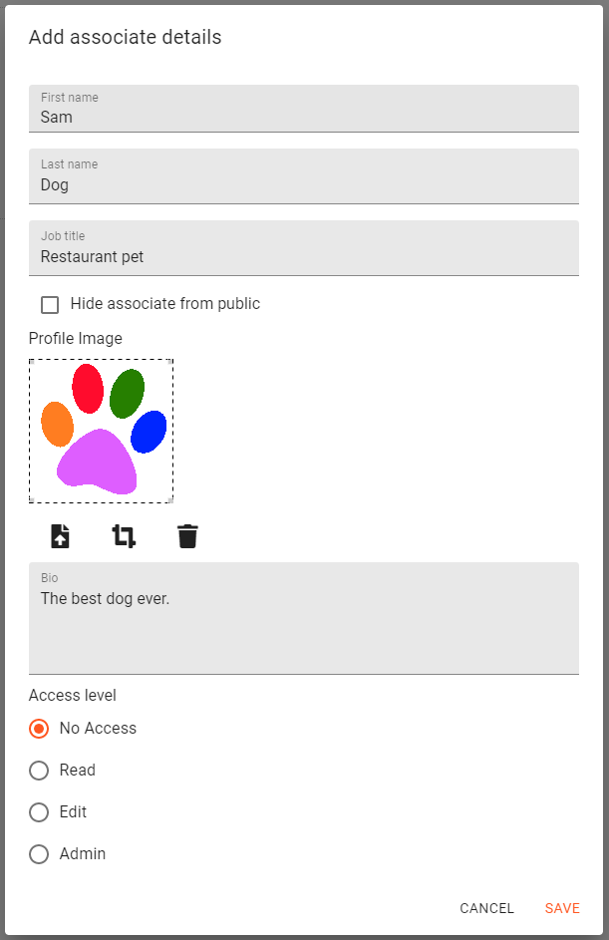
If “no access” is selected you will have complete control over the information for the associate. Fill out the fields as required and upload and crop pictures. Press save when finished.

Add an associate with read, edit or admin access
To add an associate with read, edit or admin access they must already have an verified account. Then press add associate and choose the access level desired.
The dialog will change so that an email address can be entered. Enter the email address of the associate and press save.
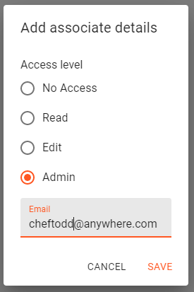
If the user does not exist or not verified you will get an error like below. If this happens the associates' account needs to be set up and validated. Contact the associate and instruct them on how to setup an account.
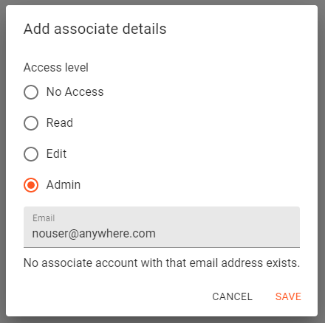

Adding, cropping and deleting associate pictures
You can add a picture of an associate by uploading from your phone or your computer using the upload button.
Note: mobile pictures currently must be taken in landscape mode, this will be fixed in a future release.
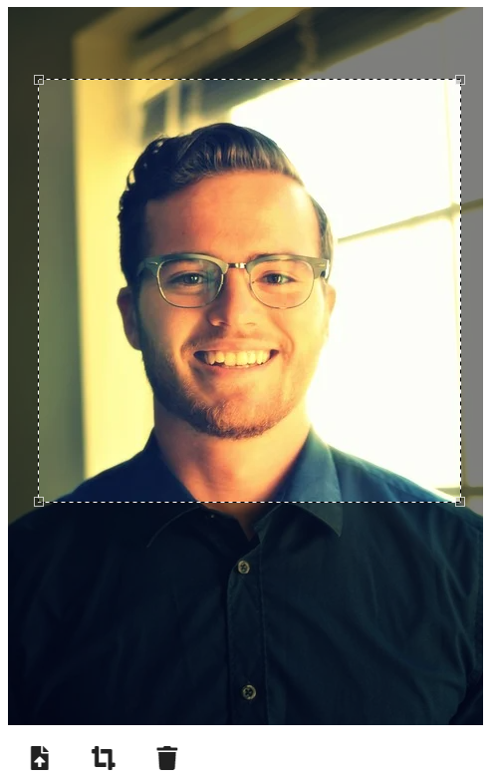
The image can be cropped using the crop box. To accept crop press the crop button again.
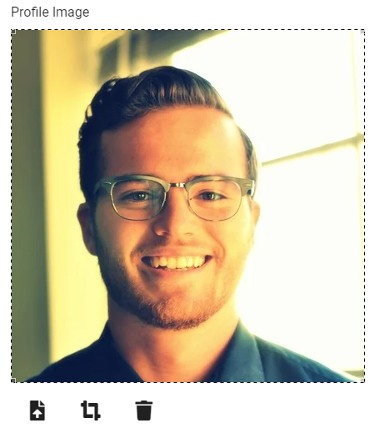
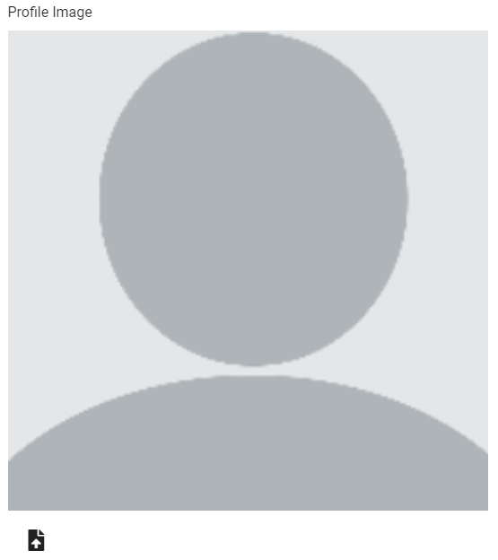
An associate can have a blank image if desired by pressing the delete button.

Editing and deleting associates
Once you have created several associates they will show in a list.
You can edit and delete them pressing the corresponding buttons on the associate.
Note: There always must be at least one admin per restaurant. If you attempt to delete the last admin a warning will be displayed.
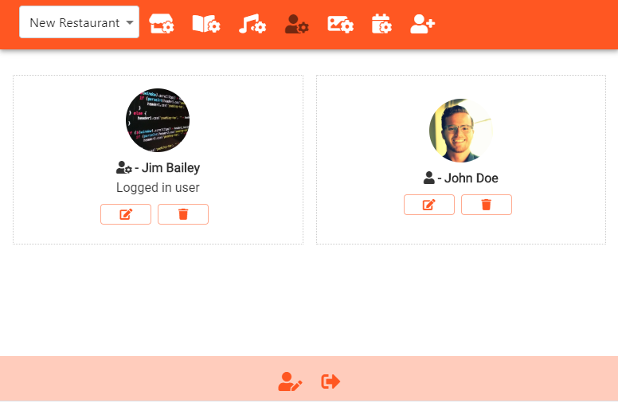

Adding photo items
Click on photo settings and the following will be displayed.
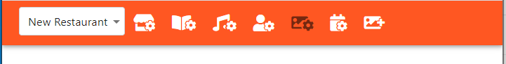

To add a photo press the add photo button.
You can add a picture from your phone or your computer using the upload button. Then add a compelling caption.
Note: mobile pictures currently must be taken in landscape mode, this will be fixed in a future release.
Next crop the image using the crop box. The crop box can be square 1:1, tall 3:4, wide 4:3 or super wide 16:9 (shown). To accept the crop press the crop button again. Play around with mixing up the crop ratios you choose for your pictures. Press save to save the picture.
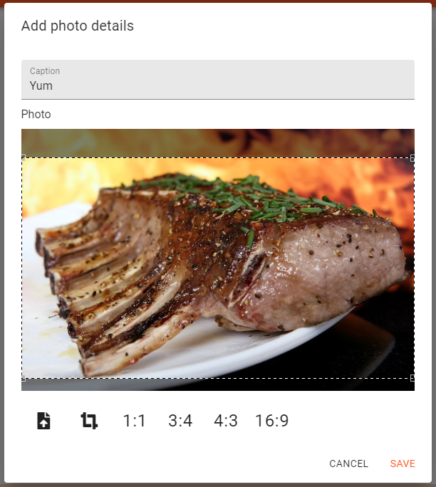
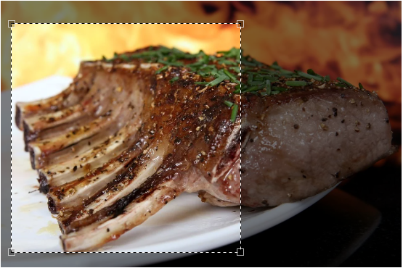
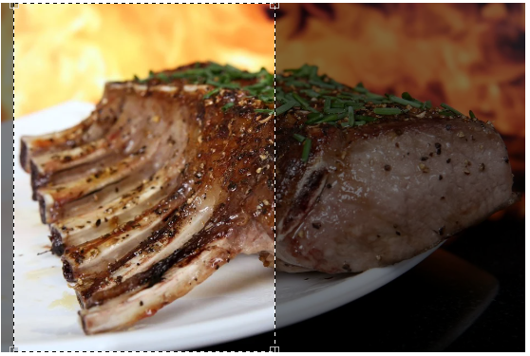
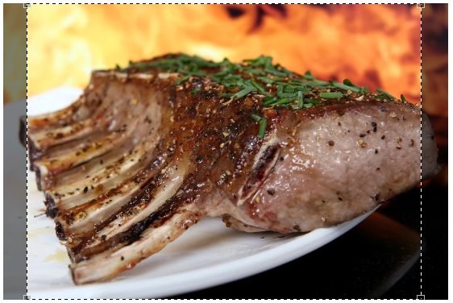

Editing and deleting photos
Once you have created several photos they will show in a list.
You can edit and delete them pressing the corresponding buttons on the list.

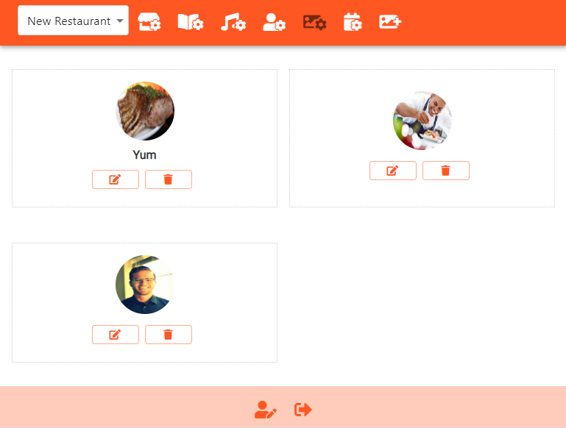

Adding menu days
Click on menu day settings and the following will be displayed.
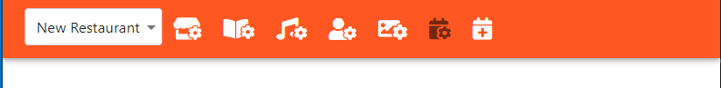
Menu days are used to set which menu items are available on a particular day.
You can also use menu days to indicate which associates are in on a particular day. These associates will have a green dot on their picture indicating so. This feature is optional. We suggest you use it if you want your customers to know which chef, bartender, server, etc. is in on a particular day. We believe it can be used to help build engagement with your customers.
We anticipate that you will have a seasonal menu or specials on certain days so you can use menu days that span a day, days of the week, a period of time or even overlap each other. It is very flexible and it is up to you how you want to use menu days.


To add a menu day press the add menu day button.
The following will be displayed. Enter a title and description. Select the from date and to date. Check off which menu items and associates you want to show. Press save.

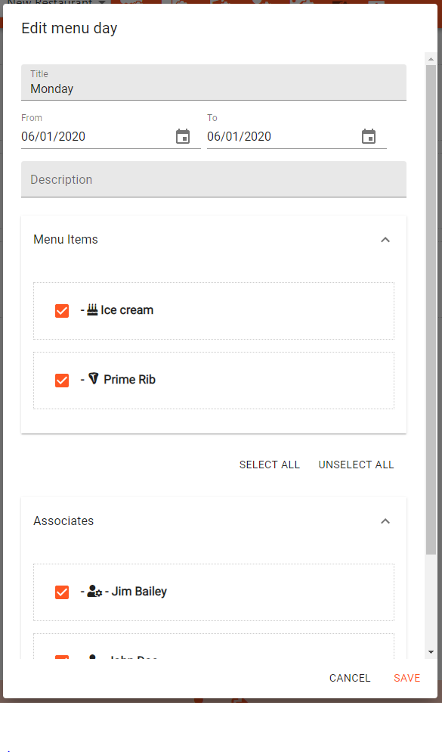

Editing, copying, deleting and menu days
Once you have created several menu days they will show in a list. You can edit, copy and delete them pressing the corresponding buttons on the menu day item.
